**What is Kafka?**

-- Kafka is just like a messaging system.

-- Producers send messages to Kafka server, and consumers consumes those messages from the Kafka server.

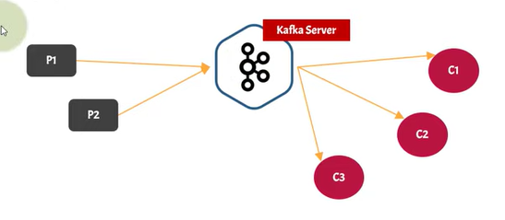

-- It is distributed platform/application.

* In production environment, kafka is referred as kafka cluster.
* A cluster is made up of more than one kafka server.
* Each kafka server is referred as Broker.
* Let us say we have 3 kafka servers/brokers running on 3 different physical machines. The combination of those 3 brokers is called as ‘Cluster’.
* Since kafka can be run from different nodes/machines, it is a distributed platform.

-- Kafka is fault-tolerant.

* Ability of a system to continue operating without interruption when one or more of its components fail.
* In kafka, cluster messages are replicated in multiple broker.

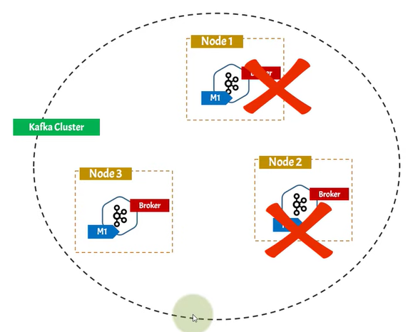

-- Kafka is scalable system.

* If user count increases, you can scale the kafka without any interruption.
* You can add a new node anytime to balance the load.
* You can increase the number of consumers.